1. **Write your own program using arithmetic operators.**

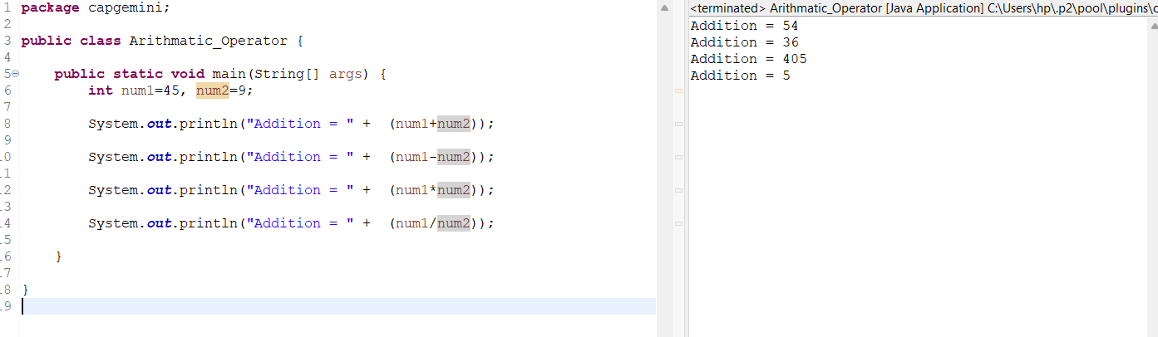

1. **Write your own program using arithmetic assignment operators.**

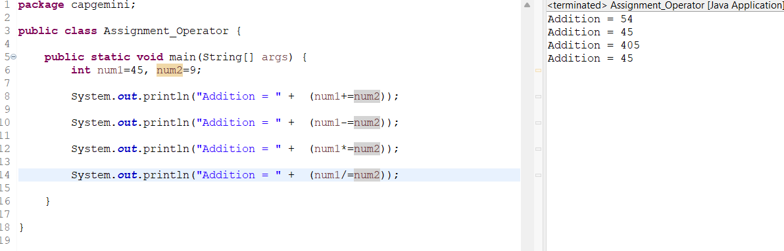

1. **Write your own program using relational operators.**

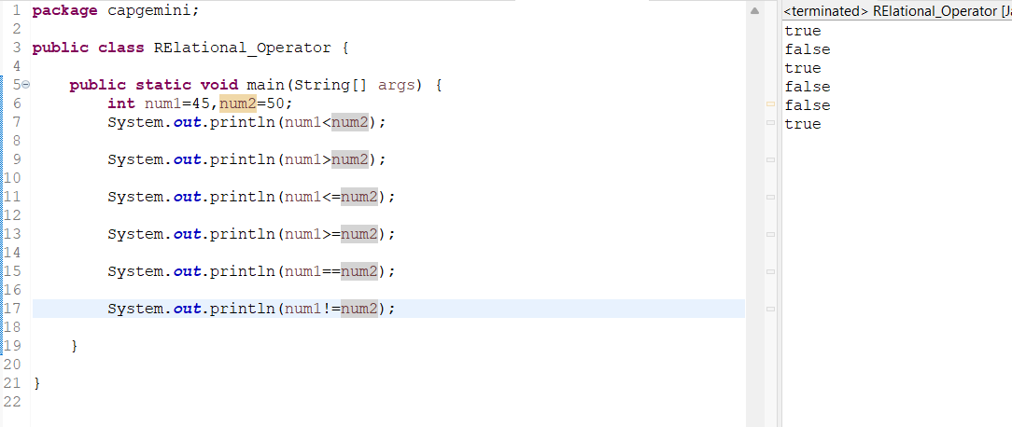

1. **Write your own program using logical operators.**

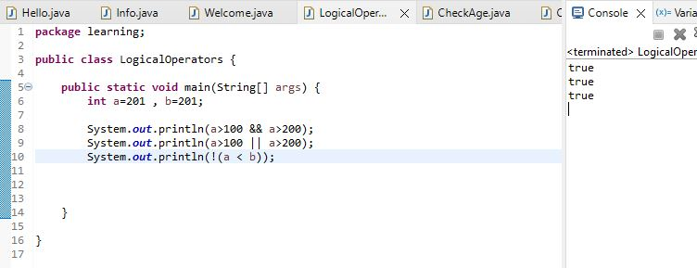

1. **Write a program to check age of student is greater than 18.**

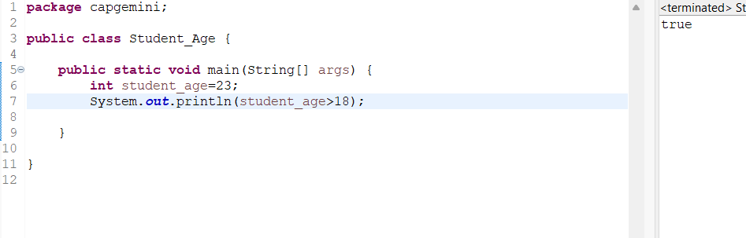

1. **Write a program to check number is even or odd.**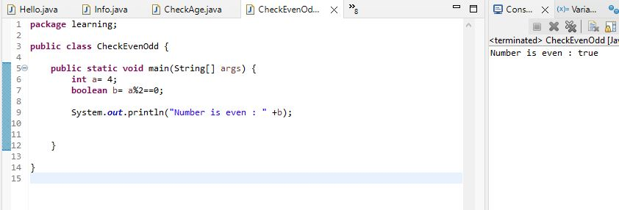
2. **write a program to check whether number is greater than 100 and 200.**

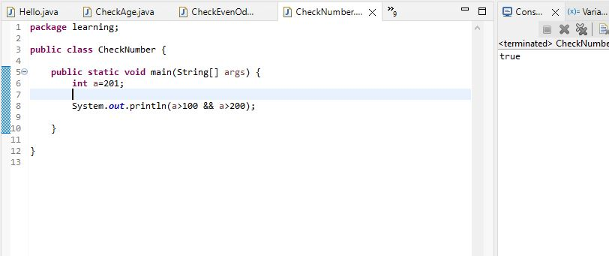

1. **write a program to check whether both numbers are same or not.**

